**IMPORTING AND DOING SAMPLE VISUALIZATIONS**

Importing can be done by *‘Load’* or *‘Transform Data’*. Transform means loading it for editing. Every editing that we do get recorded in the *‘Applied Steps’* on the right side.

On the right side go to *‘Visualization’*, go to *‘Format Visual’* then to *‘Visuals’* then go down to *‘Data Labels’* and to *‘Values’*. And in *‘General’* for *‘Title’* and other things.

**POWER QUERY**

Remove rows and columns

For changing the data type of the numbers especially in the cash right click the column and select the ‘Fixed Decimal Number’.

Go to *‘Text Filters’* and then *‘Doesn’t Contain’* and filter the words like for example Total.

If the dates are on the column basis it would work well so we need to transpose to these dates to rows. Select the columns and go to *‘Transform’* tab and *‘Unpivot Columns’.*

If the dates are like Jan, Feb, and March then change and if its not header rows change it to header rows before transposing. So go to ‘Transform’ and click Use First Row as Headers’, then select the tables wanted and ‘Unpivot Columns’

After every editing is done then select *‘Close and Apply’*

**CREATE AND MANAGE RELATIONSHIPS**

To edit the relationship double click the line connected to it

In the *‘Cross Filter Direction’* if its ‘*Single’* and if we don’t to *‘Both’* change according to the data then the result would be wrong.

**DAX (DATA ANALYSIS EXPRESSION)**

To create *‘Calculated Columns’* and *‘Measures,’* formulas.

Go to the *‘Fields’* on the right side and right click the table name to and select *‘New Measure’*

SUM is an aggregated function but it can be turned to iterative by adding x i.e, SUMX.

When we look at the image below we can observe that the profit_column is a newly created column and using *‘New Column’* and it shows same value for each row. In order to solve that problem we have to use SUMX

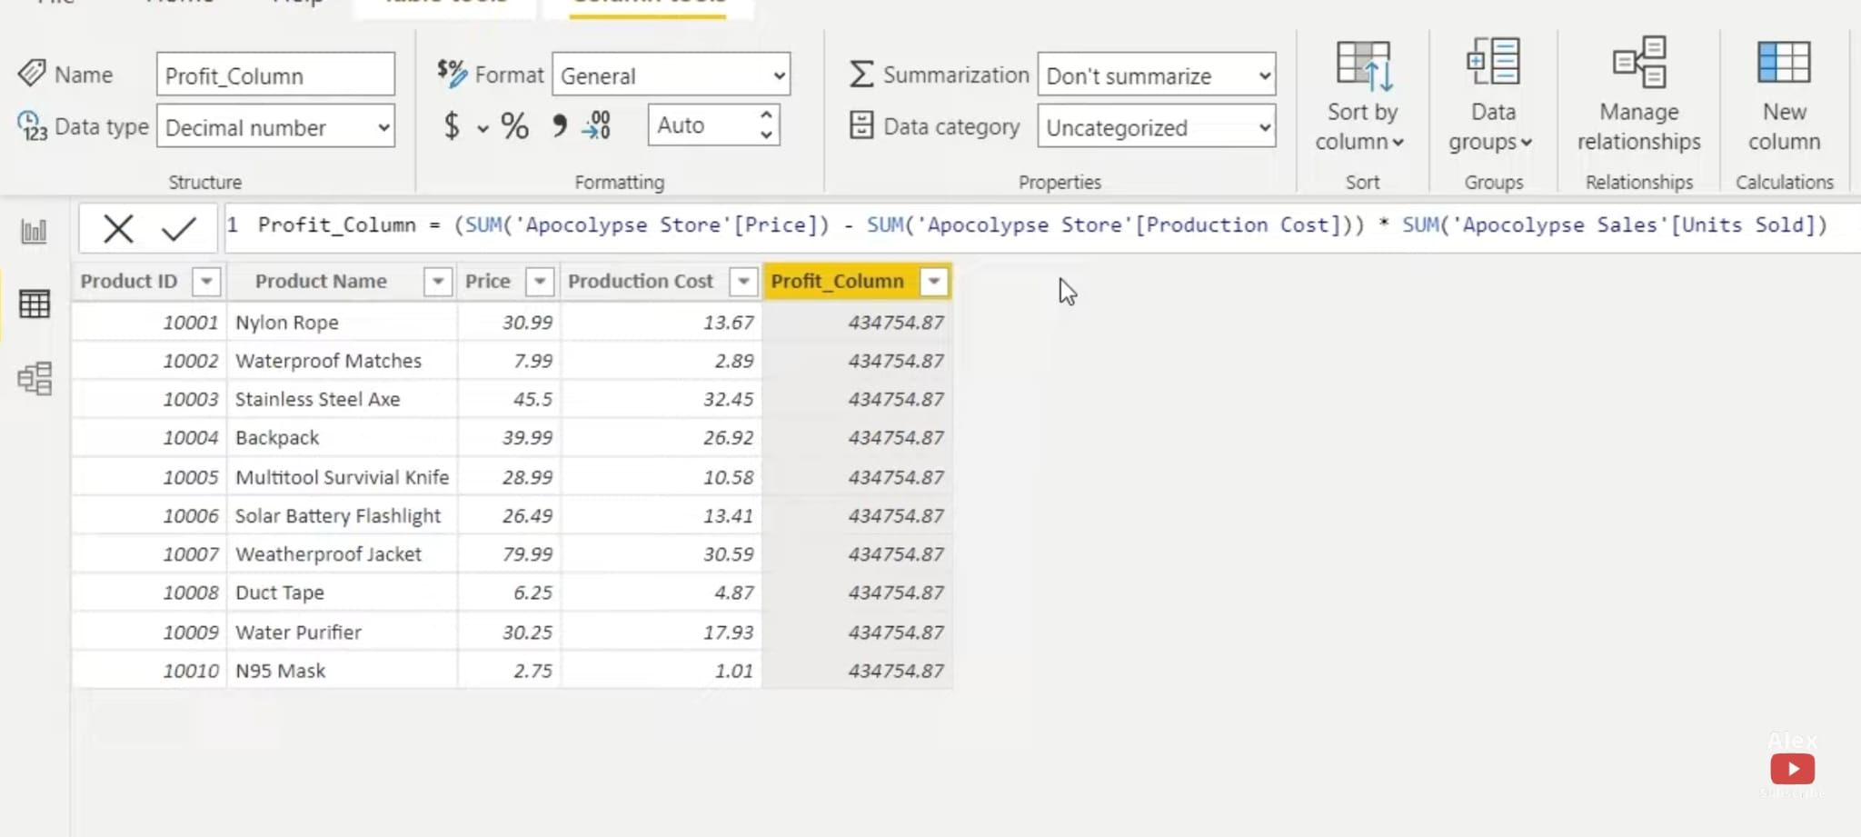

Now look at this image when it’s been updated with SUMX, it gives us the exact answer

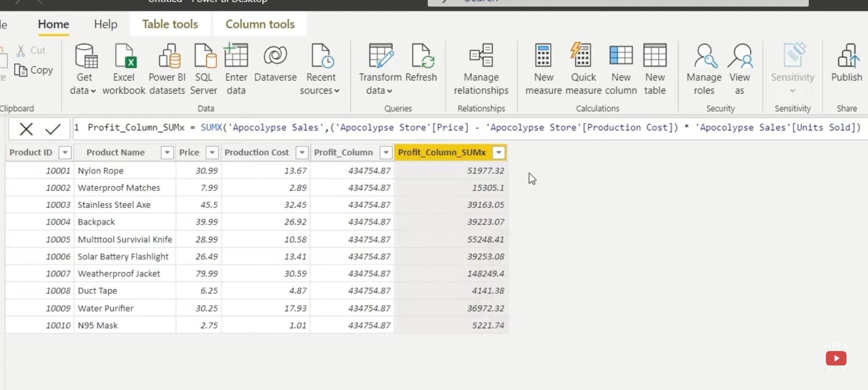

The image below becomes handy when visualising the units sold per day. If we look on the “Date Purchased” we can observe from the graph that on which days the most “Units Sold”. So instead if we apply the newly created column “Day of Week” we could able to clearly differentiate which days has sold the most units.

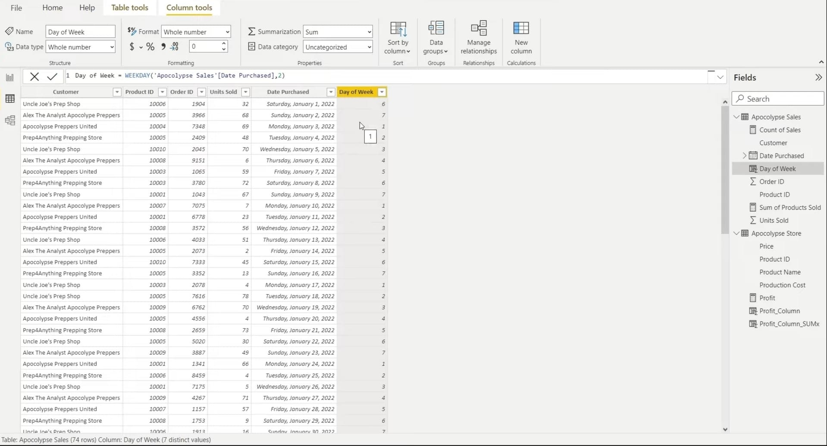

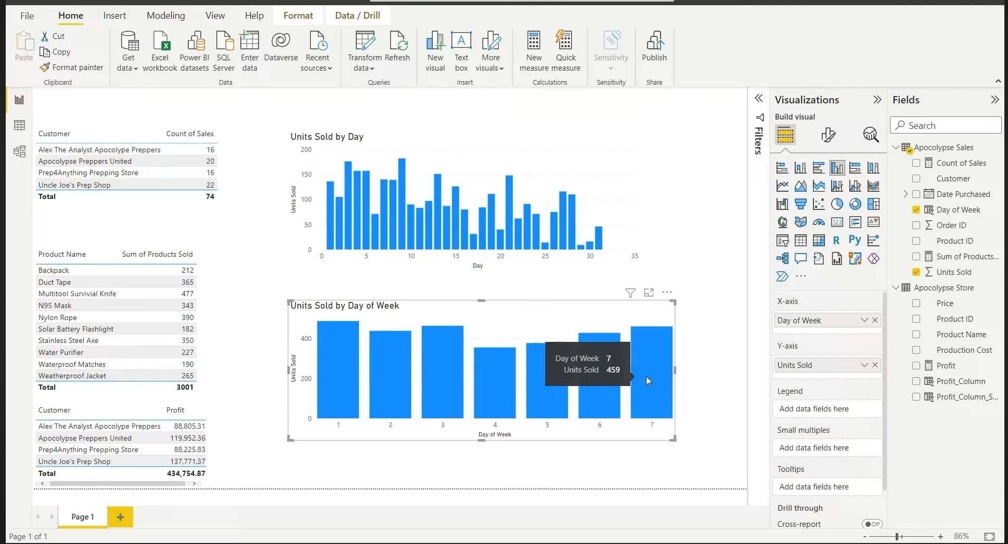

**DRILL DOWN**

When we add one additional to the attributes in the X-axis. There appears some additional features in the visualization, in which contains the drill up, down, hierarchy etc... So if we click the drill down, and then the image then it goes to another visualization.

**CONDITIONAL FORMATTING**

In this figure to access the *‘Conditional Formatting’* go to the attributes in *‘Columns’* and right click, which in the *‘Build Visual’* in the *‘Visualization’* on the right side.

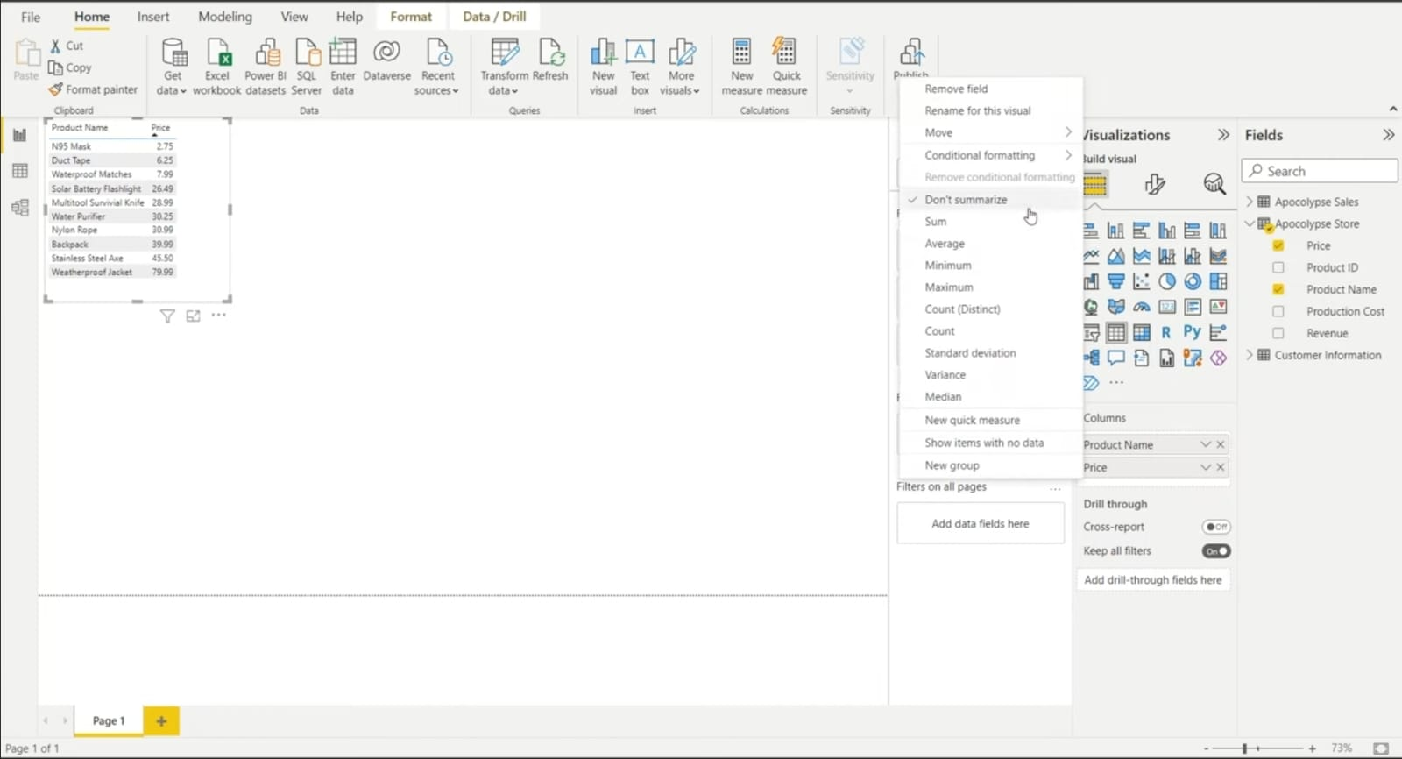

In the *‘Background Colour’* of the *‘Conditional Formatting’* change the *‘Summarization’* to *‘Minimum’* or other values otherwise it shows the same colour for all. And can add *‘Data Bars’* too.

**BINS AND LISTS**

Bins needed to be numeric

Can create *‘New Group’* by right clicking the attributes in the *‘Fields’* on the right side or even selecting the column and right clicking to select the option. Select the values and click *‘Group’*

It is just like doing the IF Statement.

In the *‘Group’* the *‘Group Type’* is *‘Bins’* and *‘Lists’*

Can do Age, Dates, etc...

**PORTFOLIO PROJECT**

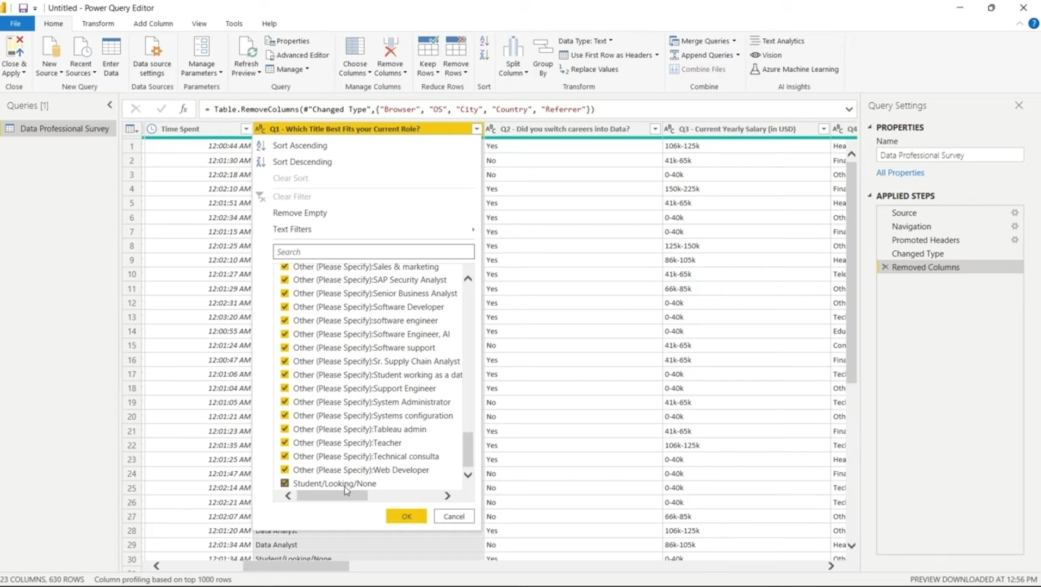

In this picture above the job type others have many options so we are going to change it to other. In order to do this select the column then go to *‘Split Column’* in the tool bar and choose *‘By Delimiter’*, from the dropdown of *‘Select’ ‘Custom’* and put *‘(‘* and select *‘Split By’ ‘Left Most Column’*

This is shown in the image given below.

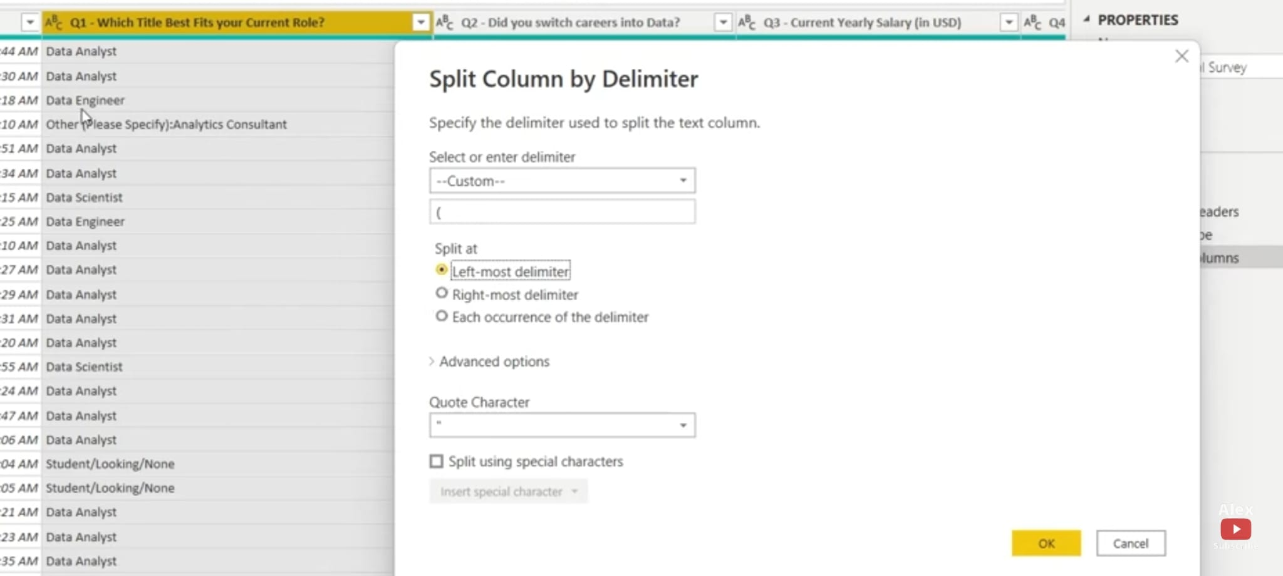

In the table named ‘current yearly salary’ first duplicate it by right clicking the column and choose *‘Duplicate Column’* then select the duplicated column and choose *‘Split Column’* in the toolbar and *‘By Digit to Non-Digit’*. So it will separate for example that is 106K-125K into three columns 106 | K-125 | K, right click and *‘Remove Column’* last which is K, right click the K-125 and choose *‘Replace Values’* in the *‘Value To Find’* write ‘K’ and click ‘OK’. So it will remove it and rest in the column will be like -125 repeat the same step ie, Replace Values with -, so the column remains with the number 125

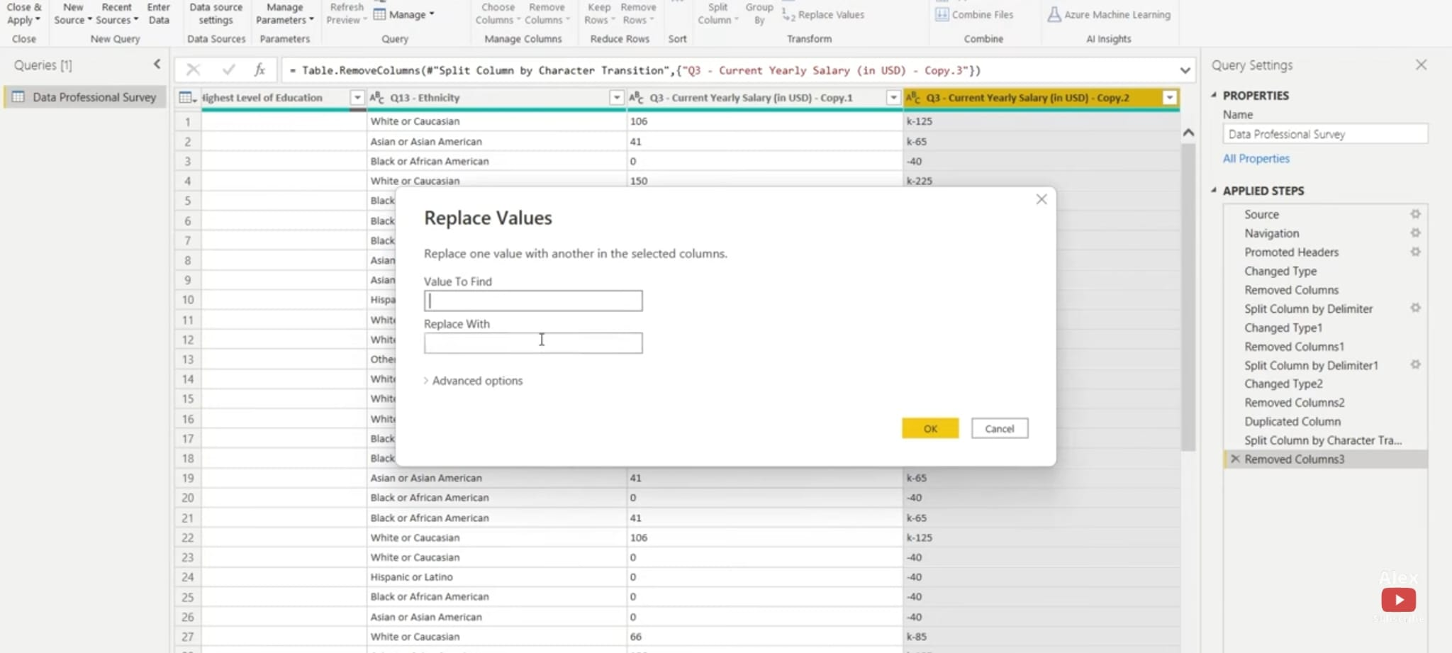

After that it had a + so replace it with 255 the value and go to *‘Add Column’* on the top and select *‘Custom Column’.* And do average and name the column as Average Salary and change its data type to *‘Decimal Number’* as shown in the image below and after it is created remove those columns with numbers

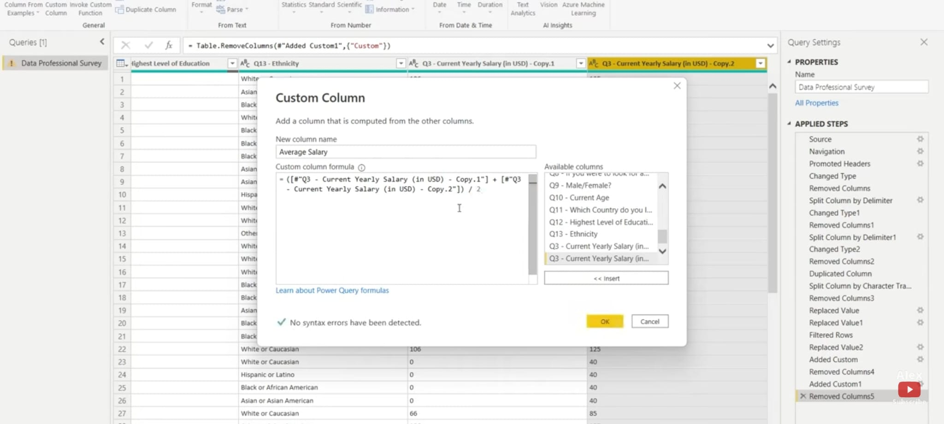

In the dashboard use *‘Text Box’*